Q) How to fix class not found exception occurring while starting tomcat server?

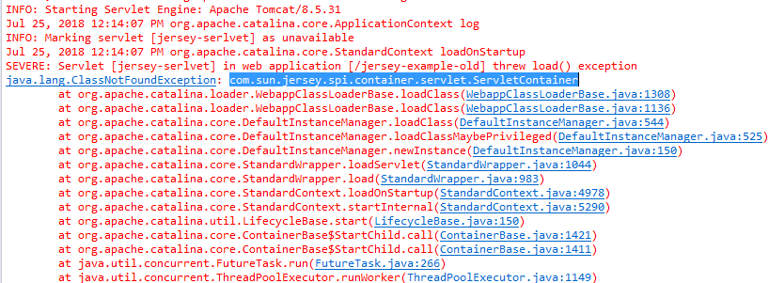

Answer:

It frequently occurs while deploying jersey Rest service.

Solution:

1)Right click on project and select properties option.

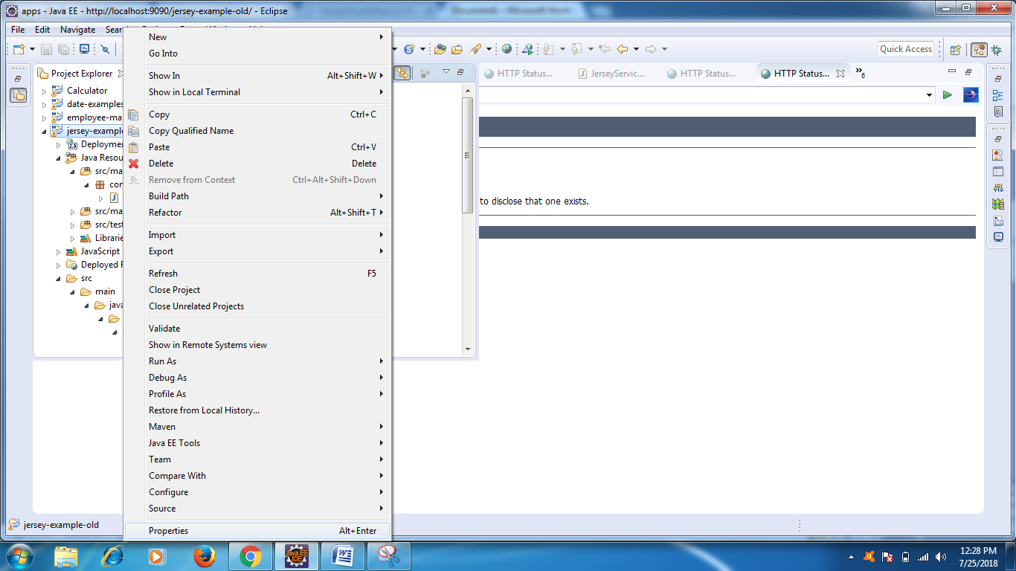

2) select deployment assembly and then click on add button at right side corner

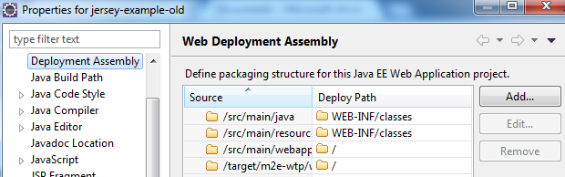

3)After clicking on Add , you will see below options, selec java build path entries and click next

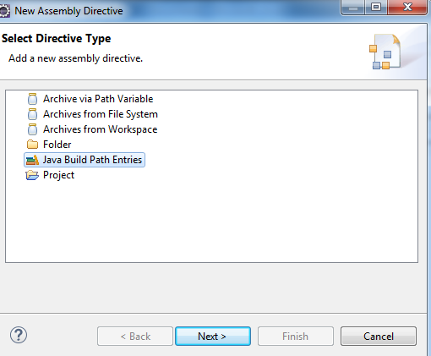

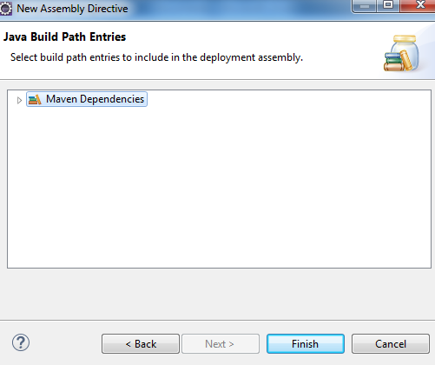

5)Finally , you will see below option, then click on apply and ok.

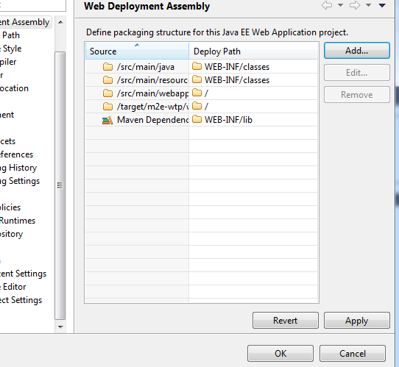

6)Restart your war file again.